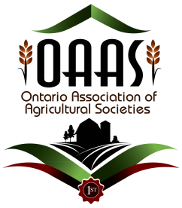

OAAS District 2 Judging School
Quilting
Friday, November 18, 2022
9:00 AM to 2:30 PM

Perth Lions Hall at the Perth Fairgrounds
50 Arthur St, Perth, ON

Registration Fee: $20, payable at the door
Registration includes morning refreshments.
Please bring your own lunch.

Please reply no later than Monday, November 14, 2022.

Contact: Rhonda Bulloch, District 2 Homecraft Director
rhondabulloch@outlook.com or 613-267-8096/613-325-6031

Class List for Judging School

If you have any of the following items to bring to enhance our judging school learning experience, please do so. We will be judging the following classes during our judging school:

1. Quilt Hand-quilted, lap size or larger
2. Machine Quilt, lap size or larger
3. Quilt Block
4. Quilt Top
5. Machine Quilted Table Runner
6. Set of Placemats Quilted
7. Crib quilt
8. Quilted bag

Judging School Schedule: (approx. and subject to change)

8:45 Registration
9:00 Introductions, logistics, outline for the day.
9:15 Jeannie Seguin, Instructor
    - What it means to be a judge.
    - Judges’ Roles & Responsibilities.
    - What is in your judging kit?
    - What judges look for in a Prize Winning Quilt
    - Types of Quilts
    - Quilt Classes suggestions
    - OAAS General Competition Rules
    - OAAS Machine Quilt Competition/Hand Quilt Competition
    - New OAAS Handbook. What is new? What changed?
    - Updated score sheet.
10:15 Break
10:30 Fun Contest
10:40 Presentation of quilts
11:00 Demo of judging a quilt and quilted items
11:15 Break out into groups and mock judging (15 minutes per class (judge 4 classes before lunch))
12:15 Lunch Break
12:30 Resume mock judging (15 minutes per class (4 classes to judge after lunch))
1:30 Review judging results and discussion
2:15 Thank you!! Wrap up and Evaluation survey sheets.
2:30 Safe travels home!

