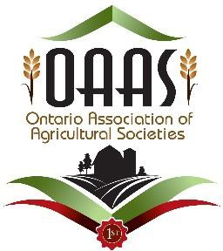

OAAS Vision For

Youth Involvement Within Agricultural Societies

Draft Handbook 2022

THIS HANDBOOK IS A DRAFT MEANT FOR REVISION AS PART OF A PILOT PROGRAM IN 2022.
The handbook is designed as a resource for agricultural societies to use, and not as a “must follow” guide. Ideas, templates, and activities should be adjusted to fit the needs of each individual agricultural society. As part of the pilot program, we hope to gather further ideas of how agricultural societies are engaging youth in their organizations.

Index

OAAS Vision for Youth Involvement in Agricultural Societies 3
Development of Youth Policy Statement for Agricultural Societies Constitutions 3
Purpose For Agricultural Society Youth Programs 3
Part 1 - Recruitment of Youth in Agricultural Societies 4
Part A: Parameters of a Youth Program 4
Part B: Ways to Recruit Youth 4
Part 2 - Implementation Options for Youth Programs 5
Model # 1 - Mentoring Program 5-6
Model # 2 – Youth Board Structure 7-8
Part 3 - OAAS Youth Policies & Procedures 9-20
- Participation, Code of Conduct, Media Release Forms 22-26
Part 4 - Agricultural Awareness Resources to Share with Youth 27
Part 5 - Governance Resources for Youth Programs and Youth Leaders 28
Part 6 - Resources for Youth Programs and Youth Leaders
- Links to Resources 29
- Take A Seat….Make A Friend Reflection Sheets 30-31
- The 9 Best Leadership Games for Skill Development 32-36
- Promoting Positive Mental Health with Youth (students) 37-43
- Mentor and Mentee Activity Templates 44-55

OAAS Vision For Youth Involvement Within Agricultural Societies:

OAAS is highly supportive of having youth involved in local agricultural societies. As a method of support, this manual and supporting resources have been developed to assist agricultural society leaders in organizing and leading programs involving youth leaders. The goal of these resources is that they constitute a starting point for agricultural societies to develop their own leadership programs. With the resources provided here, agricultural societies can edit, add to, or change the resources to suit the needs of your own agricultural society’s structure.

Development of Youth Policy Statement for Agricultural Societies Constitutions

Individual agricultural societies many wish to demonstrate their commitment to youth involvement by including a statement within their constitutions in regard to a commitment towards youth involvement. The following is a sample that may be used:

(Agricultural Society Name) is committed to the development and inclusion of youth in its program and organization. As such (Agricultural Society Name) implements a youth program which includes recruitment and mentorship of youth within its Society, modelled after the OAAS Youth Handbook.

Purpose For Agricultural Society Youth Programs

The following are reasons why we should strive to involve youth in our Agricultural Societies:

Benefits For the Agricultural Society:
- Sustaining the future of your agricultural society
- New and innovative ideas
- Providing new platforms for agricultural society (i.e., social media)
- Incorporating new technology into operation of the agricultural society
- Further developing existing and new programs

Benefits for the Youth:
- High school volunteer hours
- Scholarship opportunities (minimum # of hours to be able to apply)
- Recognized as a leader in the community
- Unique volunteer experience on resumes, post secondary applications
- Giving back to the community (helping at the fairs, events)
- Segway into other leadership opportunities
- Getting to know other community leaders – mentorship
- Networking opportunities for the future
- Building life long friendships
- Building skills – public speaking, how meetings are run, governance tips, team building – all skills that can help in the future
The ideas presented here are meant as suggestions and can be modified to fit the needs and the organization of any agricultural society.

Part 1 - Recruitment of Youth In Agricultural Societies

Part A: Parameters of a Youth Program
- The youth targeted for this program are between the ages of 14-18 in accordance with the Ontario Agricultural and Horticulture Act
- Keeping youth engaged when after this age frame
- Encouraging engagement and commitment with the agricultural society during post secondary years.

Part B: Ways to Recruit Youth

- Approach youth that are already involved in the society or they could be recruited from outside sources such as:
  - High schools
    - Ag – Horticulture classes or classes geared towards agriculture fields
    - Administrators
    - School student councils
  - 4-H clubs/connections
  - Other services groups such as:
    - Lions
    - Optimists
    - Kiwanians
    - Scouting
    - Guiding
  - Volunteers from fair events
  - Church youth groups
  - Family – relatives of current directors
  - Invite youth to work with committees to give them exposure to the board and recruit junior directors from the committees

- Inspire Youth events (4-6, pizza dinner, learn about what the Society does, how it’s run, what opportunities are available)
- Social Media – Instagram, Facebook
- Schools – social media, announcements, tv screens (for those that have it), information booths, information nights for incoming grade 9’s
- Engage youth as a group (at least in pairs – Bring a Buddy Event)
- Current junior directors (or younger full directors) reaching out and doing the personal touch
- Invite youth to come to events – fundraising events, fair set up, volunteer appreciation nights, clean up days, information nights
- Volunteers from events – attend school events (elementary & high school) and meet the kids who are already volunteering
- Have ambassadors/existing youth members speak to youth – at schools or community events or service clubs

Part 2 - Implementation Options For Youth Programs

Model # 1 - Mentoring Program

Mentorship Structure
- Agricultural Society is to identify how this program can be implemented at their society
- Identify mentors
- Set up an introduction to the program early in the year
- Identify recruitment methods that will work in your community
- Set up training plan after youth have decided how they want to move forward
- Solicit from Society committees that are interested in working with youth volunteers
- Matching of youth to their direct support mentor
- Involving youth in at least one committee of interest within the society (Job Descriptions for every committee so youth know what they are stepping into)
- Eventually after mentorship component has been completed over the first 2-year period, it could be an opportunity to implement a youth board
- Continual evaluation throughout the course of the program to help each society tailor the program to fit their participants needs
- Final evaluation to determine changes for the next group
- There needs to be a “two deep” leadership team - at least 3 mentors assigned to each group of 15 with two always present.
  - There should be a gender balance for the correlation between mentors and youth (Example: 10 Female youth to 5 male youth, 2 female mentors 1 male mentor)
- Background information that could be shared with youth includes:
  - Governance
  - Constitutions
  - Budgeting and Finance
  - Board Operations
  - Responsibilities of being a Board Member
  - Insurance
  - Sponsorship
  - Youth and Mentor should have a training plan in place where they will decide together what the youth wants to learn during their time with the program
◦

Choosing Your Society’s Mentors To Work With Youth
    - Must be willing to listen and support youth and their ideas
    - Must be willing to provide a vulnerable sector check
    - Are asked to give a minimum of a two-year commitment to this role to help develop the youth they are working with
    - Must take this role seriously
    - Are willing to try new things
    - Must have the time to commit to this role
    - Must be an experience agricultural society member
    - Willing to advocate between youth and committees that the youth are involved with
    - Continue to guide those who complete the program and engage them in mentoring the future participants in subsequent years

Mentor/Mentee Activities

In addition to structured discussions, you, your team, and your mentor may choose to focus on particular activities that will assist you in your personal and professional development. Below is a list of activities that you may choose from. Feel free to add any other activity that you and your team decide would be useful.

Activities to consider:
- Resume Review
  - Bring a copy of your current resume. Work with your mentor and your team to provide suggestions on improvement.
- Mock Interview
  - Ask your mentor to provide you with a mock job interview. Each member should take turns doing this so plan enough time so each can take a turn or plan on separate meetings with your mentor. These may also take place over the phone.
- Shadowing Day
  - Spend a day with your mentor. Attend meetings and other activities to better understand a day in the life of your mentor.
- Attend a Trade Show
  - If possible, consider going to a trade show with your mentor. Get a chance to see a variety of industry specific organizations and/or the general process for networking
- Attend a Professional Organization
  - If your mentor belongs to a professional organization such as Rotary, Young Presidents Organization, or another other prestigious organization, see if it is possible to attend one of these and meet the various types of leaders that attend.
- Hobby or Leisure Activity
  - It may sound a bit odd, but you may consider a leisure activity that your mentor enjoys. This may be a trip to the golf course, tennis courts, or any other environment that gets them talking

** See also Leadership Resources – for a series of documents to support mentoring

Model # 2: Youth Board Structure

- Agricultural Society establishes a Youth Executive (President, Vice President, Treasurer, Secretary)
- Identifies projects for the youth board to work on (ie. Social Media, Specific Committees, Family Program etc.)
- Establish at least two board members to be the advisors for the Youth Executive
  - Attending all meetings of Youth Board
  - Assisting with documentation and operation of their Executive
- Give the Youth Board a budget to accomplish identified projects
- Holding regular meeting of the youth board to formalize their work and plan
- Prepare reports for the Youth Executive to bring to the Society Board
- Youth Executive should be invited to all Society Board Meetings to deliver reports to the board
- Youth Report should be part of the standing Agenda Items of the Society Board Meetings
- Youth Board should endeavour to create plans for future initiatives/projects for Youth Boards that come after the current group
- The Society Board needs to allow for these ideas to be developed and give them consideration for the future.
- Ambassadors, within the age range of 14-18, could also be included in this board as a member of the youth board

Youth Board Structure Sample Objective:
A fun and rewarding club where students can learn about responsibility, agriculture, our community, public speaking, planning, commitment and our fair. The two objectives of the Junior Fair Board is to create a fun and interactive experience for fairgoers to get up close and personal with all the aspects of our fair while expanding their knowledge of agriculture. The second goal is to get local youth involved in the fair to teach them exactly how our fair comes to be each year.

Plan of Action:
- First, establish a group of youth interested in the fair board.
- Find an Adult willing to act as our supervisor. (Sole purpose of Adult is for health and safety and to act as a supervisor/mentor not a member of the Junior Fair Board)
- Permission would have to be obtained from the Ag. Society to operate a Junior Fair Board. (Inquire about insurance etc.)
- Establish an “Executive” (ie. President, VP, secretary, treasurer)
- Develop permission form for parents to sign

- Formulate a plan on what exactly the program would look like (ie. Where are our points/people of interest)?
- Obtain sponsorship from local organizations.
- Spread the Word!
- Create schedule for the day of

Proposed Events:
- Saturday of the Fair
- Run a circuit every hour and a half
- Meet inside arena
- Scavenger hunt through children’s crafts
- Talk to Agricultural Society President about their role
- Vote on Viewer’s choice quilt
- Visit horse show
- Visit the barn
  - Talk to 4-Her/show person
  - Interactive demo
- Talk to Ambassadors
- Visit select vendors
  - I.e. beekeepers, milk booth, etc.
- Wrap-up inside arena

Youth Board Operation:
The Youth Board would be responsible for the above activities as well as helping in the setup/take down of the fair. We propose members receive 20 hours of community service. Members must be between 14-18 years of age. Members must attend 70% of the meetings in order to receive community service hours.

Members will be sectioned into “committees” (similar to Fair Board) and each committee will be responsible for one activity. This includes creating ample activity for participants and coordinating with fair board members relating to their activity (i.e person in charge of children’s craft activity would coordinate with mentor/advisor).

Conclusion:
The proposed activities would be a fun interactive way for people to better experience our fair and country life. The Fair Board would join together many age groups in our community under the main objective of fun and education. Introducing youth into our fair board is the way of the future!

Developed by: Flos Agricultural Society & North Simcoe 4-H Club (2018)

Part 3
OAAS Youth Policies & Procedures

The policies presented here are for provincial events, but these policies and procedures could serve as a model and can modified to fit the needs and the organization of any
agricultural society.

Policy Type: Youth Policies 7.1
Policy Title: Volunteer – Youth General Policies and Procedures
Adopted: October 22, 2016

Reviewed and/or amended:

The Ontario Association of Agricultural Societies (OAAS) is passionate and committed to ensuring the delivery of safe and educational youth programs through activities delivered at the provincial and District levels.
The OAAS will strive to ensure the safety, health and well-being of all youth involved in the programs by:
- Considering risks management implications in all youth program activities
- Adhering to all organization goals, responsibilities and missions during programming
- Behaving in a way that will avoid any unnecessary risk of the safety, health and well-being of all involved.
- Treating all people involved in a fair and courteous manner with respect and dignity
- Acknowledging the zero tolerance for alcohol or drugs during any youth program activities
- Recognizing the use of vulgar or inappropriate language is not acceptable
- Understanding that a volunteer and youth should never be alone together, unless safety dictates otherwise. If there is a need to speak privately to a youth, ensure the discussion is not out of sight from others, just out of hearing
- Communicating with any youth participants using technology and social media only for the purpose of the program and also copying another adult such as parent or another adult volunteer
- Emotional, physical, verbal, mental or sexual abuse of any individual participating/attending an OAAS event/activity will not be tolerated
- Any acts of discrimination and/or harassment of the basis of race, nationality or ethnic origin, colour, age, religion, family status, sexuality or disability is unacceptable.
- Maintaining privacy of youth is important. Respect will be given to the confidential nature of information received regarding youth involved in OAAS programming, events and/or activities.
All youth participating in OAAS related programming will be required to review with their parent/ guardian and sign a Participant Code of Conduct acknowledging their understanding of their expectations according to the OAAS.

OAAS Volunteers & Youth Policies and Procedures

Policy Type: Volunteer – Youth Policies and Procedures 7.2
Policy Title: Criminal Reference Check/Vulnerable Sector Check
Adopted: May 15, 2018

Reviewed and/or amended:

The OAAS adheres to procedures recommended by the RCMP in regard to Police Records Check for not for profit organizations serving youth. All Directors must complete an appropriate Police Records Check for initial approval. Subsequently, Directors must complete a Police Name/Records Check every three years (36 months from the date of their previously filed Police Records Check).

This policy applies to all OAAS Provincial and District Staff, Directors, Executive and volunteers working with youth.

Volunteers who are involved with mentorship of Youth Boards should have a Criminal Reference Check.

Volunteers: Require an appropriate Police Records Check every three years, however, if there is break in service during that time, a new one will be required.

Acceptance of Vulnerable Sector Check / PRC
Require an appropriate Police Records Check must be an original, bear an authorized signature and stamp of the local police service jurisdiction, and will be reviewed and a true copy signed by the Manager will remain on file with OAAS.
In the case of a volunteer working with youth at a fair level the OAAS recommends that the VSC/PRCs will be signed by the fair President and Secretary and remain on file at the fair.

Acceptance of Police Records Check completed for Outside Organizations

OAAS will accept a Police Records Check previously completed for another volunteer agency provided that:
The Police Records Check very clearly includes all the required searches. Are less than 36 Months old when received by OAAS based upon the Police
Agency date stamp of completion.

Acceptance of On-Line Police Checks

Police Records Check competed by an outside Organization using the services of an approved agency will be accepted by OAAS providing the check was completed within thirty-six months.

Releasing Police Records Check information

Results of the Require appropriate Police Record information will only be released to the OAAS Executive as necessary. No third-party requests will be honored unless judicially requested and bound by law.

Retained copies of Police Records Check

File copies of Police Records Check shall be retained as a permanent record and may be archived electronically.

Zero Tolerance

OAAS maintains a zero tolerance against individuals / volunteers who have charges or convictions relating to abuse, violence, sexual offences, crimes against children, weapons and selling of controlled drugs and substances. Individuals found to have these charges / convictions will not be accepted as volunteers.

Criminal Charges

Criminal convictions that lead the OAAS to believe that the safety of youth members, or the integrity of the OAAS will be jeopardized, will result in the non-acceptance or dismissal of an individual.
.
Volunteers with criminal charges or convictions may request their volunteer application or volunteer status be reviewed by the OAAS Appeals Committee.

Where a volunteer is currently charged with an offense his/her volunteer responsibility will be suspended and placed on hold. They can be considered for reinstatement once all legal proceedings are finalized.

If a volunteer has previously submitted a VSC/PRC and has a valid one on record but has been charged criminally since it was filed, it is the duty of the volunteer to disclose the fact that they have been charged criminally to their supervisor. Each situation will then be reviewed on a case- by-case basis by an OAAS Appeals Committee as to whether the volunteer may continue their service or be suspended or terminated.

OAAS Volunteers & Youth Policies and Procedures

Policy Type: Volunteer – Youth Policies and Procedures 7.3
Policy Title: Transportation of Youth
Adopted: May 15, 2018

Reviewed and/or amended:

Parents are responsible for transporting or arranging for transport of their Youth to and from OAAS activities.
The OAAS is not responsible for the transportation of youth to events sponsored by the OAAS and their Districts by non-related volunteers.
Where non-related volunteers are transporting youth to an OAAS Provincial or District event, at least one volunteer must have a VRC/PRC on file with the OAAS
Where public transportation is not available or not feasible:
- permission to transport youth must be granted by parents/guardian in writing;
- no youth must be allowed to be alone with an adult;
- vehicles owned and operated by volunteers must be insured by the owner under the Provincial law of their domicile and be operated by duly licensed and insured drivers;
- OAAS strongly suggests volunteers who use their vehicles to transport passengers carry a minimum of $2,000,000 Liability insurance, and further recommends $1,000,000 per passenger on their vehicle to ensure they are fully protected.
- volunteers who drive passengers do so at their own risk;

OAAS Volunteers & Youth Policies and Procedures

Policy Type: Volunteer – Youth Policies and Procedures 7.4
Policy Title: Abuse
Adopted: May 15, 2018

Reviewed and/or amended:

Emotional, physical, verbal, mental or sexual abuse of any individual participating/attending an OAAS event/activity will not be tolerated, nor is the use of profanity, crude remarks or crude actions.

Alleged abuse of a Youth will result in the alleged abuser’s suspension of duties and removal from the event and will be reported to the Police (911) and/or Child Protection Authority.

Child Abuse Prevention Policy Statement

All complaints or risk of physical, emotional and/or sexual abuse must be reported immediately to Police (911) and to Child Protection Authority. Failure to do so may result in suspension from the program and criminal charges under provincial child protection legislation. If the person is uncertain about circumstances, it is prudent to consult with local authorities.

Information relating to a current situation must be reported to the local Child Protection Authorities. Information of an historical nature involving a former volunteer who is now an adult should be reported to police.

Once the disclosure has been declared, the recipient reports the alleged disclosure, to the Police (911) and Child Protection Authorities.
Upon completing the report to authorities, the person must then report to the OAAS President, and/or the OAAS Manager.
The OAAS President and/or the OAAS Manager will immediately suspend the alleged abuser or inform the Agricultural Society President or Manager to do so.

Procedures

The following steps should be taken immediately when any member or parent contacts a member of OAAS with a complaint of abuse or neglect against a member, or if the police contact OAAS to inform us of allegations or charges against a current member:

- Advise the person that you report to and ensure you or your supervisor or both will report the occurrence to Police (911) and Child Protection Authority and the OAAS President and or OAAS Manager. No judgment statement should be made about the alleged abuser, nor should you show alarm or anger.

- Remove the Youth from any further danger if warranted.

- Advise the person he/she will hear directly from the Police and/or Child Protection Authority.

- Advise the Youth or parent that all information will be kept confidential and will only be provided to those who require it for the protection of all involved.

- Contact the Police and/or Child Protection Authority, the OAAS President and/or Agricultural Society manager or president immediately following the disclosure.

- As soon as possible, complete the Youth Abuse Report form to be sent to the OAAS Manager.

Appendix A
Abuse Policy: Dealing with Youth abuse or Youth protection allegations:

  - Listen, believe and reassure. Stay calm. Don’t panic or overreact to the information. Listen compassionately and take what the person is saying seriously. Don’t criticize or tell the person they misunderstood what happened.
  - Ensure that discussions with the Youth occur in a private setting, (using the “two adult” rule)
  - It is critical to use open-ended questions. Do not lead. “Tell me what is happening” is a good open-ended question.

It is imperative that the Youth does most of the talking so as to avoid any leading by the adult in the collection of information.
  - When the disclosure has been given, it is now time to report it to Police (911) and the Child Protection Authority. Do not probe for any details.
  - Document the actions taken, (date, location, who is involved). Be careful not to delve too deeply if you feel it will be a police matter.

OAAS Volunteers & Youth Policies and Procedures

Policy Type: Volunteer – Youth Policies and Procedures 7.5
Policy Title: Chaperones
Adopted: May 15, 2018

Reviewed and/or amended:

The safety and protection of our volunteers and youth participants is of the utmost importance to the OAAS. At no time should an adult volunteer be alone in a private place with a non-related youth. Where youth are present, or expected to be present in a private place, a minimum of two adults, who have completed their Police Name/Record Check are required to be in attendance.

Requirements for Overnight Chaperones:

For any activities or events that include an overnight portion:
- Overnight Chaperones are required, and the following requirements must be met:
- Chaperones are required to stay on the same premises as the delegates.
- Where the overnight activity has both male and female participants at least one male and one female chaperone must be available.

Chaperone/Youth Rooming Option Guidelines:

- It is strongly recommended that each youth be chaperoned by a blood relative/legal guardian.
- Under no circumstances will one individual chaperone share a room with one individual youth.

Staff and volunteers who hold a Duty of Care towards youth serve in responsible positions and must conduct themselves in accordance with OAAS’s Code of Conduct. Those serving in responsible positions have a clear obligation to care for and ensure the safety of youth. As such, these volunteers serve in safety-sensitive positions. This means that persons in responsible positions are (a) prohibited from the use of, and (b) must not be affected by, alcohol, any drugs or substances that impair their performance while they are responsible for ensuring the safety of youth under their care.

See Chaperones Code of Conduct F14.10

OAAS Volunteers & Youth Policies and Procedures

Policy Type: Volunteer – Youth Policies and Procedures 7.6
Policy Title: Position of Trust
Adopted: May 15, 2018

Reviewed and/or amended: July 3, 2018

Volunteers are often in a “Position of Trust” with young people while carrying out their volunteer duties. Parents entrust their children with OAAS volunteers who are responsible for the supervision and safety of youth members. As such, the volunteers have an obligation to take reasonable care to avoid causing foreseeable harm to a person.

Volunteers uphold the values and policies of the OAAS and their local agricultural society. Examples of Positions of Trust may include but are not limited to: chaperone, event volunteer, OAAS District Director, local agricultural society representative, or member of the OAAS Provincial Board of Directors.

OAAS Volunteers & Youth Policies and Procedures

Policy Type: Volunteer – Youth Policies and Procedures 7.7
Policy Title: Activities Involving Youth
Adopted: May 15, 2018

Reviewed and/or amended:

Programs should be planned in such ways that eliminate situations where there would be access to a youth in private by an adult. In this way, we are taking steps to ensure no harm comes to a youth by an adult as well as to avoid false accusations.

Compliance with this Policy is mandatory for all OAAS Provincial or District events. Compliance with this Policy is strongly recommended to all Agricultural Societies.

OAAS Volunteers & Youth Policies and Procedures

Policy Type: Volunteer – Youth Policies and Procedures 7.8
Policy Title: Code of Conduct Youth
Adopted: May 15, 2018

Reviewed and/or amended:

The OAAS is committed to ensuring we have the right volunteers in the right roles. Our volunteers lead the way by providing meaningful, leadership experience for our youth.

Staff and volunteers who hold a Duty of Care towards youth serve in responsible positions and must conduct themselves in accordance with OAAS’s Code of Conduct. Those serving in responsible positions have a clear obligation to care for and ensure the safety of youth. As such, these volunteers serve in safety-sensitive positions. This means that persons in responsible positions are (a) prohibited from the use of, and (b) must not be affected by, alcohol, any drugs or substances that impair their performance while they are responsible for ensuring the safety of youth under their care.

The OAAS is dedicated to the personal development of youth while providing a positive impact on partners, Member Societies, volunteers and communities in Ontario. In order to achieve this mission, the OAAS Code of Conduct applies to all participants of the program,
staff, Directors and volunteers. It addresses the general rules of conduct necessary to maintain the standards of the OAAS, and each individual is expected to follow the code of Conduct.
Failure to do so may result in dismissal from the OAAS program.

- Participants will respect, adhere to and enforce rules, policies and guidelines established by the OAAS.
- OAAS members, volunteers, guests and stakeholders shall be treated using appropriate and courteous manners as the participant himself or herself would like to be treated while ensuring respect for people and property.
- Positive image is expected at all times. Participants will conduct themselves in a courteous and respectful manner, exhibit good sportsmanship, and act as a positive role model for those around them. Behavior must be conducive to a friendly, safe and fun learning environment.
- Emotional, physical, verbal, mental or sexual abuse of any individual participating/attending an OAAS Provincial and/or District event/activity will not be tolerated, nor is the use of profanity, crude remarks or crude actions.
- Maintaining the privacy of participants is important. Respect will be given to the confidential nature of information received regarding fellow participants and program affairs.
- Any acts of discrimination and/or harassment on the basis of race, nationality or ethnic origin, color, age, religion, family status, sexuality or disability is unacceptable.

- Possession and/or use of alcohol, recreational or illegal drugs, or illegal inhalants is forbidden by participants (regardless of age of majority) at activities held for attendance by OAAS members.
- Participants will regard it as their personal duty to know their responsibilities thoroughly and are expected to be responsible to their peers.
- Participants will ensure that outside interests do not jeopardize their judgment and competence as contributing participants.
- Districts may have additional guidelines and/or policies that need to be adhered to. It is the responsibility of the participant to ensure that he/she is aware of and understands these additional rules and responsibilities.

See OAAS Form F14.9

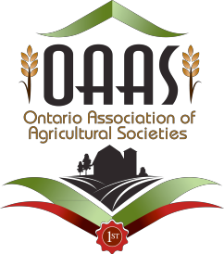
ONTARIO ASSOCIATION OF AGRICULTURAL SOCIETIES PARTICIPATION AGREEMENT FORM
The Ontario Association of Agricultural Societies (OAAS) provides an annual educational program of Fair Ambassadors from across Ontario aged 16 and up. All participants must complete the Participant Agreement Form in order to participate in the OAAS Ambassador program. If the participant is under 18 years of age, the parent/guardian should complete this form prior to the participant’s involvement. It is the responsibility of the parent/guardian to notify/update the OAAS of any changes to the information on this form.

Within the Participant Agreement Form, some information that is requested may be sensitive in nature. OAAS staff and Volunteers collect a variety of information in order to ensure the connection, safety and care of all participants. The purpose of the information collected here is to provide the OAAS with the information needed to facilitate OAAS activities, and to be able to respond in the event of an emergency.
This information is also used to keep participants up to date on activities within the OAAS including programs, services, and initiatives. Information will be gathered, stored and destroyed in accordance with the Canada Health Act and privacy laws.

SECTION 1: PARTICIPANT CONTACT INFORMATION (PLEASE PRINT)

Agricultural Society: | OAAS District:
Participant Full Name (First Middle Last): | Preferred Name (i.e. Chris instead of Christopher):  
Birth Date (MM/DD/YYYY): | Gender  : |  | Male: Female: Other:
Address: | City/Town:
Postal Code: | Phone Number:
Email Address:

Participants Room Number: | Cell Phone Number:
Chaperone’s Full Name and Room Number: | Chaperone’s Cell Number:

SECTION 2: PARTICIPANT RELATIONSHIPS
Primary Contact (Parent/Guardian)
*In the event of an emergency this will be the first person contacted*
Full Name (First Middle Last): | Relationship to Participant:
Home Phone: | Cell Phone:
Email: | Address:

Secondary Contact
Full Name (First Middle Last): | Relationship to Participant:
Home Phone: | Cell Phone:
Email: | Address:
Agricultural Society Contact

Full Name (First Middle Last): | Role at Ag Society:
Phone Number: | Cell Phone:
Email: | Address:

SECTION 3: HEALTH AND SAFETY INFORMATION

This information is voluntary and participants are not required to complete this portion of the Participant Agreement Form, however, this information is gathered for communication with health care providers in the event of an emergency. Please include any information that the OAAS organizers may require to ensure the participant’s safety, and a positive OAAS Ambassador Program experience.
3 A) Emergency Contact (If parent/guardian not available)
Name: | Relationship to Participant:
Phone: | Alternate Phone:

3 B) Health Care Provider of Member
Physician/Medical Practice Name:
Phone

3 C) Medical / Behavioural / Allergies / Dietary
□
□
□
□
Are there any medical conditions, disabilities, family circumstances, cultural requirements or other concerns of which the OAAS Ambassador Program organizers should be aware? If so, please explain here, or speak directly with the activity organizer.

Medical / Behavioural
Description/Details:

Allergies

□ ◻ ◻

Drugs Environmental Food Other
□

Description/Details:
Dietary Requirements
Vegetarian/Vegan
Celiac/Gluten Free
Lactose Free
Other

SECTION 4: MEDIA RELEASE

While participating in OAAS activities, photos and videos of participants will be taken. These photos are typically used to record memories and promote the OAAS. Please indicate below your consent to the use and reproduction by the OAAS of any and all photographs, video recordings and audio recordings taken of myself or my child for use on OAAS websites, in print and other media for the purposes of promotion, illustration, advertising or publication and without compensation. All such photographs, video recordings and audio recordings and all recorded media, prints and created media from the content shall constitute the property of the OAAS. In addition, the undersigned hereby consents to authorize the publication of the name of the participant. Important Reminder: Photos, images and media may appear in electronic form on the Internet or in other publications outside of the OAAS’s control.

I consent. I DO NOT consent.

Signature of Adult Participant Date of Signature

For participants under age 18: The undersigned hereby certifies that as the parent or guardian of the participant I give my consent on his/her behalf.

Signature of Parent or Guardian Date of Signature

SECTION 5: OAAS CODE OF CONDUCT AGREEMENT
The OAAS is dedicated to the personal development of youth while providing a positive impact on Members, Volunteers and communities in Ontario. In order to achieve this mission, the OAAS Code of Conduct applies to all participants of the OAAS program in Ontario (all Staff, Volunteers and Members). It addresses the general rules of conduct necessary to maintain the standards of the OAAS program. To truly be an organization of leaders building leaders, each individual is expected to follow the code of conduct. Failure to do so may result in dismissal from the OAAS program. In case of dismissal, no portion of fees whatsoever will be refundable. Interpretation of this code is at the discretion of the OAAS and/or those Volunteers and/or staff responsible for the activity, in consultation with others as appropriate.
- The OAAS participants will respect, adhere to and enforce rules, policies and guidelines established by the OAAS.
- OAAS Members, Volunteers, guests and stakeholders shall be treated using appropriate and courteous manners as the participant himself or herself would like to be treated while ensuring respect for people and property.
- A positive OAAS image is expected at all times. OAAS participants will conduct themselves in a courteous and respectful manner, exhibit good sportsmanship, and act as a positive role model for those around them. Behaviour must be conducive to a friendly, safe and fun learning environment.
- Emotional, physical, verbal, mental or sexual abuse of any individual participating/attending an OAAS event/activity will not be tolerated, nor is the use of profanity, crude remarks or actions.
- Maintaining the privacy of OAAS participants is important. Respect will be given to the confidential nature of information received regarding fellow OAAS participants and OAAS program affairs.
- Any acts of discrimination and/or harassment on the basis of race, nationality or ethnic origin, colour, age, religion, family status, sexuality or disability is unacceptable.
- Possession and/or use of alcohol, illegal drugs or illegal inhalants is forbidden by participants (regardless of age of majority) at activities held for attendance by OAAS Members. Any disregard for this policy will result in disciplinary action.
- OAAS participants will regard it as their personal duty to know their OAAS responsibilities thoroughly and are expected to be responsible to their peers.

- OAAS participants will ensure that outside interests do not jeopardize their judgment and competence as contributing OAAS participants. OAAS participants will strive to the best of their abilities to promote the mission and vision of the OAAS
Date of Signature
Signature of Parent/Guardian
For parents/guardians of participants under 18: I have reviewed this Code of Conduct with my child and he/she agrees to abide by this Code. We both understand that any breach of the OAAS Ontario Code of Conduct could be cause for dismissing the child from the activity and/or from the OAAS program.
Date of Signature
Signature of Participant
For participants of all ages (Youth (Member and Non-Member) and Volunteers): I have reviewed this Code of Conduct and I agree to abide by this Code. I understand that any breach of the OAAS Code of Conduct could be cause for dismissing me from the activity and/or from the OAAS program.

SECTION 6: CONSENT TO PARTICIPATE

Date of Signature
Signature of Parent/Guardian
For participants under 18: In permitting my child to participate in OAAS activities, I, the undersigned permit my child to participate in the full range of activities. I authorize that ifI, the undersigned is incapable or cannot be reached within a reasonable period of time during a medical emergency, as determined by the OAAS, the OAAS is granted permission to designate the emergency personnel to the OAAS Volunteer, in the event of an accident or illness affecting the child to authorize on my behalf all procedures (including admission to the hospital) and necessary treatment herein as he/she may deem essential for the care and
well-being of the child. Such action is to be only when immediate contact with the parent/guardian cannot be made.

I have read and understood the above policies and have taken care to notify the OAAS of any special needs/considerations for my child as previously outlined above.

PRIVACY STATEMENT
The Ontario Association of Agricultural Societies (OAAS) Privacy Statement – the OAAS respects the privacy of its members, volunteers, donors, sponsors, staff and stakeholders. We are committed to ensuring that appropriate measures and safeguards are in place to protect specific information

Youth Leadership - Code of Conduct for Adult Volunteers

I, , will work to carry out the OAAS Mission Statement: The OAAS is a resource for its members, providing leadership through communication and education, and encouraging the promotion of a rural way of life in Ontario. I further agree that I will adhere to the Code of Conduct as set out in the OAAS Policy Manual and recorded below.

The OAAS Board Member’s Code of Conduct
This Code of Conduct applies to all Directors, including ex-officio Directors, staff, and non-Board Members of Board Committees.

The OAAS Board of Directors is committed to teamwork and effective decision-making. Towards this end Board Members and Youth Mentoring Volunteers will:
- Endeavour to represent the broader interests of Agricultural Society members and/or stakeholders.
- Adhere to the Agricultural and Horticultural Organizations Act, the OAAS Constitution and Bylaws, and Policies.
- Seek to balance their contribution as both an advisor and learner.
- Be honest with others and true to themselves.
- Refrain from trying to influence other Board Members outside of Board Meetings that might have the effect of creating factions and limiting free and open discussion.
- Maintain the highest standards of integrity.
- Be willing to be a dissenting voice, endeavour to build on other Director’s ideas, offer alternative points of view as options to be considered, and invite others to do so too.
- On important issues, be balanced in one’s effort to understand other Board Members and to make oneself understood.
- Once a Board decision is made, support the decision even if one’s own view is a minority one.
- Not disclose or discuss differences of opinion on the Board with those who are not on the Board.
- The Board should communicate externally with “one voice”.
- Respect the confidentiality of information on sensitive issues, especially in personnel matters and at all times what occurs “in camera” meetings.
- Be an advocate for the organization and its mission wherever and whenever the opportunity arises in their own personal and professional networks.
- Follow approved meeting agenda.
- Limit discussions at Board and committee meetings to matters of concern.
- Use established and approved communication channels when questions or concerns arise and not resort to utilizing public forums, media and/or social media for a personal platform of complaint.
- Disclose one’s involvement with other organizations, businesses or individuals where such a relationship might be viewed as a conflict of interest at a meeting (see Conflict of Interest Policy).
- Refrain from giving direction, as an individual Board Member, to any member of staff.
- Refrain from investigating or discussing staff’s performance with staff members or stakeholders without Board authorization.
If any of the above standards are not conformed to the penalty of:
First offence, the guilty party shall be immediately asked to leave the meeting and/or event and be notified by letter that they have received a first offence warning.
Second Offence, the offending party will be notified by registered mail that they are no longer a member of the Board. The respective District will be notified of the Board actions and asked to name a replacement immediately.
I hereby acknowledge that I have read and understood the above information and agree to the terms.

Signature Date

Part 4: Agricultural Awareness Resources To Share With Youth
Main page of videos - https://www.farmfood360.ca/

Beef - https://www.farmfood360.ca/en/beef/

Beef farm family (less than 5 minutes) - 360" https://youtu.be/A7VD2yXB3tc
360 tour ( 6 minutes) - https://www.youtube.com/watch?v=xtE1o-ZE9yg

Dairy - https://www.farmfood360.ca/en/dairycowfarms/voluntary-milking-system/ 360 tour (6 minutes) https://www.youtube.com/watch?v=FCazO5p-BQc
Dairy farm family (5 minutes) https://www.youtube.com/watch?v=2vyOWs9YHxA&t=15s

Egg farms - https://www.farmfood360.ca/en/eggfarms/enriched360/ Egg farm family - https://youtu.be/LpzdXslhde0
Free run (5 minutes) - https://www.youtube.com/watch?v=qNpQyJqglWk

Sheep - https://www.farmfood360.ca/en/sheepfarms/sheep360/ https://www.youtube.com/watch?v=ENlXc7rFmKA

Grain farm - https://www.farmfood360.ca/en/grainfarms/grain360/

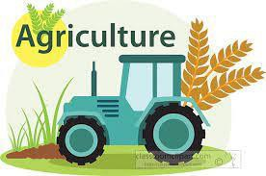
Apple farm - https://www.farmfood360.ca/en/apple-orchard/360-video/

Part 5: Governance Resources For Youth Programs and Youth Leaders

A PowerPoint as a brief overview of Governance for Agricultural Societies is available as an attachment on the OAAS website – www.ontarioagsocieties.com; under the Youth tab. This powerpoint can be adapted to suit the needs of any specific agricultural society, and expected to be a model that can be adapted for your use.

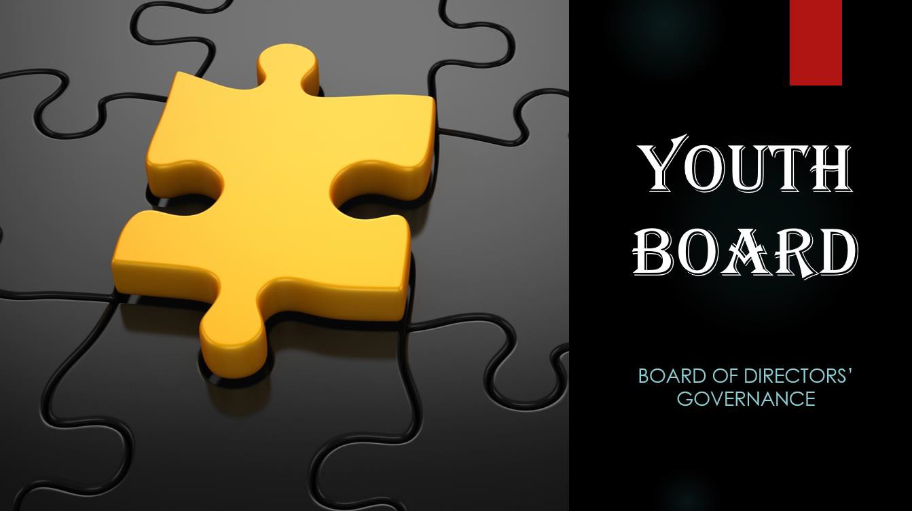

Part 6: Resources For Youth Programs and Youth Leaders

Video: Every Kid Needs A Champion – Rita Pierson – Ted Talk
Summary: This video is focussed on teaching, but is applicable to anyone working with children/youth. The key messages about supporting and being there for youth is emphasized.
https://youtu.be/SFnMTHhKdkw

Soul Pancake: Take A Seat - Make A Friend
Summary: This video was created as a social experiment by a group of university students to show people how much we are all the same. The experiment has been replicated many times since. This can be used as a discussion point, or could be used as kick off discussion using the question starters provided. https://www.youtube.com/watch?v=HfHV4-N2LxQ

** See next two pages for Follow up question activity for Take A Seat – Make A Friend

Engaging Youth, Serving Community: Social Change Lessons from a 4-H Rural Youth Development Program
Berkman Center Research Publication No. 2013-7
Summary: Research Paper from the Berkman Center (U.S.A.) providing background and research findings of the value of Youth and Adults working together for social change.

Engaging Youth, Serving Community: Social Change Lessons from a 4-H Rural Youth Development Program by Donna Peterson, Barbara Baker, JoAnne Leatherman, Michael Newman, Sally Miske :: SSRN

Reflection Questions “Take A Seat…. Make a Friend”
After viewing the “Take A Seat … Make Friend” video, find someone that you don’t know very well. Choose some questions to explore together.
You may also wish to move onto a new partner after 4-5 questions.

- Find one thing you have in common.

- Talk about something you wish you had done differently.

- Talk about an experience that changed your life.

- Share one thing on your bucket list.

- Talk about an “elder” who inspires you

- When did you first fall in love?

- What scares you most about the future?

- What do you want to be remembered for?

- What do you love most about being the age you are?

- Talk about a place in the world you find “spiritual.”

- What gives you a sense of wonder?

- Talk about a time when a stranger helped you?

- Talk about one unexpected thing you are grateful for.

Reflection Questions - Continued “Take A Seat….Make a Friend”
- What bends your mind whenever you think about it?

- What excites you most about the future?

- What is your earliest memory?

- What do you hope never changes?

- What advice would you give your younger self?

- What age do you wish you could permanently be?

- What is one thing you had had to unlearn?

- What small thing makes your day better?

- What is something you will never do again?

- What’s the best and worst thing about getting older?

- Who is a “young leader” you admire?

- As you get older, what do you become more afraid of?

- Have you ever changed your mind about something big?

- What do you regret not doing?

The 9 Best Leadership Games for Skill Development
By Peter Landau | Sep 13, 2018

Source: The 9 Best Leadership Games for Skill Development - ProjectManager.com (ProjectManager.com is an online software for managing projects and teams, and free trials can be explored on-line).
Leadership is not an academic pursuit. Leaders aren’t working in the abstract, but rather in the here and now. They are thrown into situations and must act. Their success is not based on clever interpretations of famous quotes or methodologies, but on unifying a group to achieve a common goal.

That doesn’t mean that book smarts are a waste of time. By all means, read about what makes a great leader, but temper that cerebral exercise with something you can really sink your teeth into. We’re talking leadership games. Yes, games.

Games are fun, but they’re also about stealth learning. You learn better when you’re engaged, and what’s more engaging than having a good time? The following leadership games can both make you a better leader, and improve the leadership qualities of your team members.
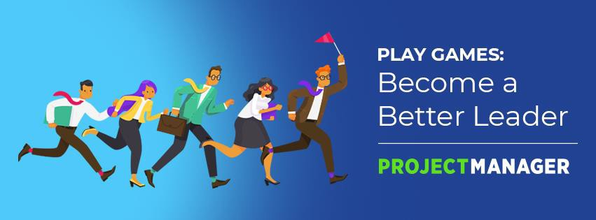

- Pass the Hoop

This game involves having a group stand in a circle and hold hands. One of the people in the circle has a hula hoop around their arm. Now, try to pass that hula hoop all the way around the circle.

You can see what this activity works to strengthen, right? Certainly teamwork, which is crucial for any leader, as they’re not working in a vacuum. There’s problem solving, too. But most importantly, communication, which might be the most fundamental skill for any successful leader to have.
- Maneuver the Minefield

First, blindfold one person in the group. Then, set up an obstacle course or minefield around them. Next, establish a limited set of words that can be said to help direct the blindfolded person through the minefield. For example, just four words: left, right, forward, back.

The object of this leadership game is to guide the blindfolded person through the minefield without incident. You can do this in the office or outside on
a company retreat, but either way you’re going to develop your communications skills and one of the more elusive leadership bonds — trust.
- Stand Up

Here’s a simple one that requires no props. You need only two people, who are sitting on the floor. They face one another, with the soles of their feet together and holding hands. The object of this game is to have both players stand up at the same time. It’s a great way to develop teamwork and trust, while working on problem solving and collaboration.

- Improv Night

Improvisation is a good way to get a team to bond, which is one of the responsibilities of a leader. Improv helps with communication, self-awareness, self-confidence and creativity. Plus, it helps you pay attention and listen better.

Set up an audience and a group to perform. In the classic improv set up, have the audience shout out a location, a profession and a situation (like coffeehouse, cop and buying a donut). Whatever you choose, it’ll be silly, educational and sure to get the creative juices flowing.

Related: 10 Super Fun Team Bonding Games

- Desert Island

What objects would you want to have if you had to survive on a desert island? Break up into teams and have them choose five items that they all can agree are essential to their survival.

We’re not talking about your favorite album or book, but life-or-death decision-making, which will illustrate people’s priorities and also show how willing they are to compromise and work together for the greater good. It’s a great exercise to learn how to work with limitations, and it involves planning, risk-taking and communications, all the basic skills of leading a project.
- Shape Shifting

You’ll need a rope, one that has been tied at both ends into a loop. It should be large enough for everyone to hold with both hands while they stand together in a circle. Now, tell the group to make a shape, such as a circle, square, triangle, etc. The group then tries to put the rope on the floor in that shape.

Repeat this and add complexity, asking them to make more difficult shapes, such as a horse, chicken, etc. Only the catch is, now they must communicate non-verbally, only with hand gestures. As you continue, remove even the hand gestures for communication. When done, discuss the experience and explain the importance of communication.
- Leadership Crest

Some people might not have a family crest, but everyone knows what they are: a visual representation of that clan’s strengths. It’s something that explains the family. Apply that same idea to leadership, and have everyone make a crest that represents the values, beliefs and ideas of a great leader.

Have them break the crest or coat of arms into four categories, leadership skills, values that help influence others, recent accomplishments and what you like most about your current work. Which section was easiest? Does anything there reveal something about you that others might not know? Are the company’s values reflected on the crest?

This game focuses on an often overlooked leadership quality, alignment. It’s important to have your values align with your accomplishments and your companies values.
- You’re a Poet, and You Didn’t Know It

Writing a poem is a great way to stretch one’s creativity and explore leadership concepts. You can write the poem yourself or break into small groups, each with the task to think about leadership in nonlinear ways to discover new perspectives.

Related: 30 Team Building Activities

To offer a bit of direction, require that the poem relate to the five senses, have action words and discuss abstractions. But when choosing words, make sure they’re specific, meaningful to you and, of course, poetic (musical and pleasing). Afterwards, have a group discussion and see what surprising ideas were revealed.

- Leaders You Love

There are many great leaders in every field and era, with plenty of leadership styles ranging from transformational to transactional. We can learn from that history. Often our sights are set on specific leadership skills that resonate with us, but that myopic view can leave other important attributes in the shadows.

So, get a few small groups together and have them discuss leaders they know or admire and why. Then get everyone together and talk about leadership with the examples they culled in the smaller groups. Not only will the results be enlightening, it’ll help the group bond.

The next series of activities in the pages that follow are based on working with youth, mostly in a school setting. The activities, however, lend themselves greatly to group
building and skills building for youth and when working with youth. These activities could serve as a model and can modified to fit the needs and the organization of any agricultural society.

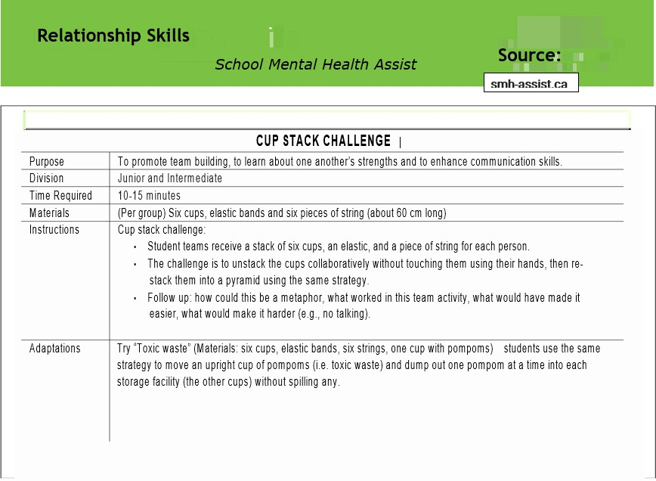

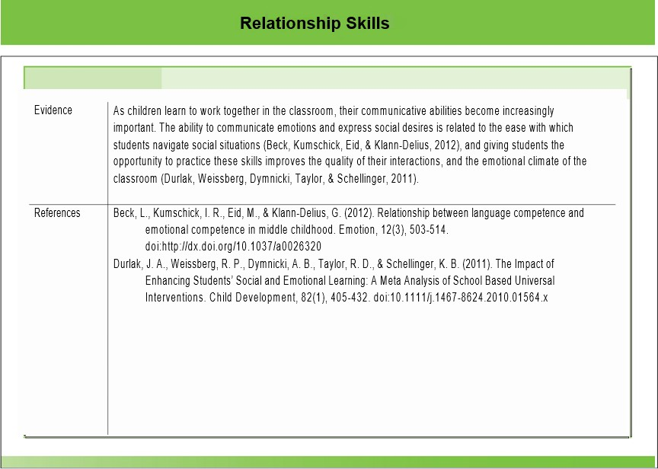

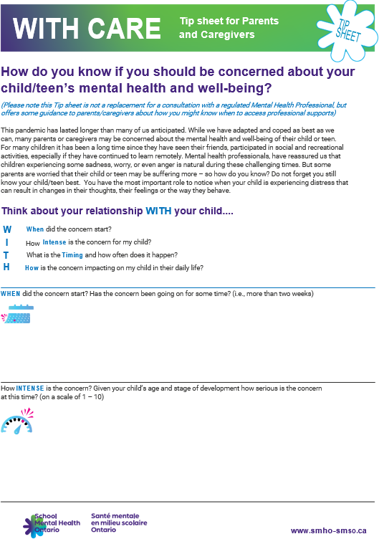

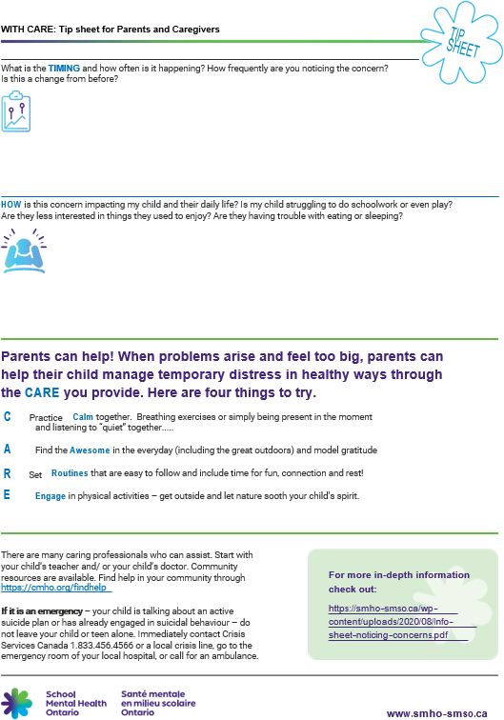

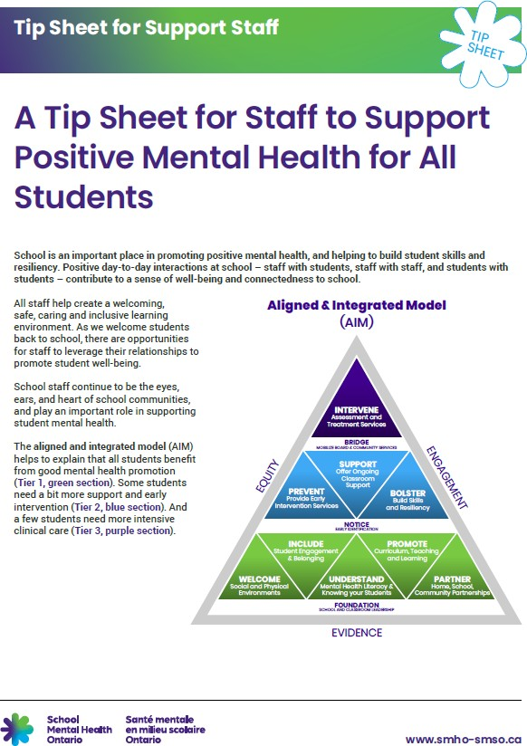

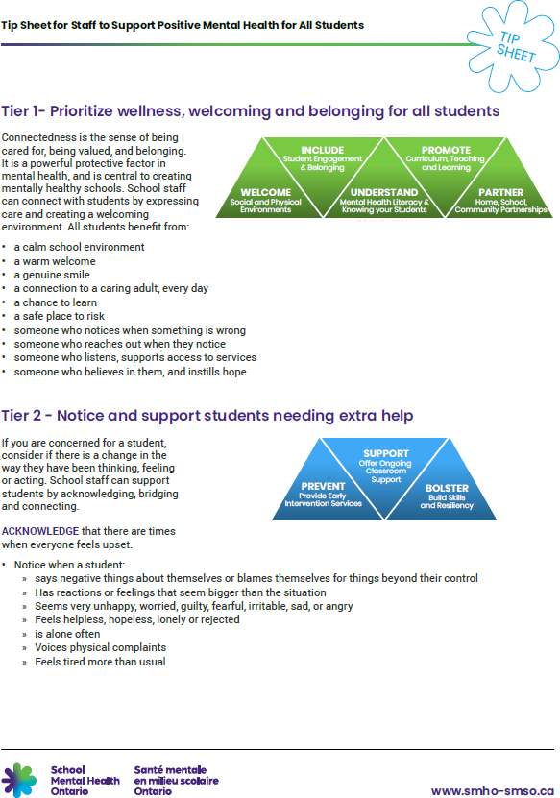

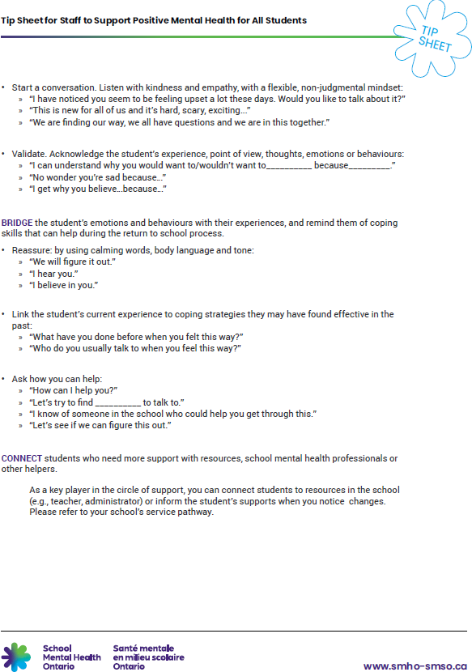

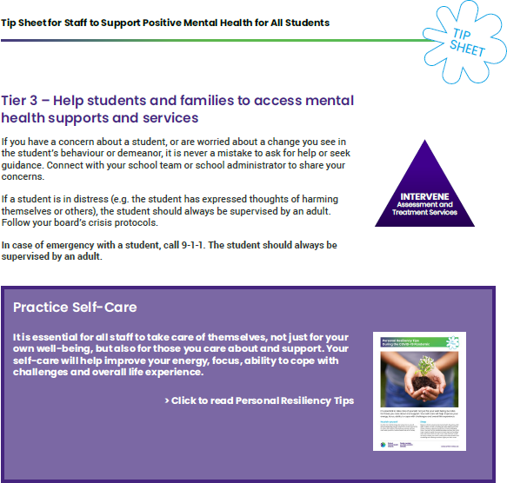

Mentor/Mentee Discussion Templates & Activities

Source: Adapted From -
https://www.uvu.edu/getinvolved/lead/docs/mentor_mentee_discussion_
templates_activities.pdf

The purpose of this section is to provide Mentors and Mentee Teams with a structured approach in working together. Use the templates to facilitate discussion, write notes, record reflections, and to list additional questions or topics that may emerge from your discussion. Keep in mind that these templates and activities are provided to you as optional guidelines/resources.
As important questions or other topics of interest emerge from your conversation, utilize the additional pages to organize your own conversation. Working with your Mentors and Mentee Teams or individual partnerships should be an enlightening and enjoyable experience for both of you.
This is a professional relationship and one where team members and mentor will have expectations of one another. Begin exploring expectations at the “Meet Your Mentor” event in the fall. In addition, consider the following list of dos and don’ts as you engage in your mentoring relationship:

Helpful Reminders:
  - Be Respectful
  - Seek to learn from your mentoring experience.
  - Look for ways to add value to your mentor/mentee. Remember a birthday; write a thank you note, send an encouraging text, etc…
  - Keep commitments
  - Help your mentor/mentee know specific ways you are growing from your mentoring experience
  - Be mindful of time commitments
o Youth: Be sensitive to the time the mentor shares with you and do your best to accommodate their schedule. (The mentor is volunteering their time to support your leadership development).
  - Be on time
  - Respect your boundaries. Don’t ask questions that are too personal unless permission is given
  - Keep confidential information confidential

Mentor/Mentee Discussion Template # 1
Introductory Meeting
During your first discussion, consider the following questions with your mentee/mentor:

- Where did you grow up? What kind of family are you from?

- What significant experiences did you have that shaped their life?

- What is your educational background?

- What fair or agricultural experiences have you had in your life?

- What significant events shaped the life of your life?

- What are you passionate about?

- What would you most like to do to support your fair or agricultural society?

- What else have you learned about your mentee(s)/mentor that is interesting to you?

Before completing your meeting:

  - Establish next meeting (date, time & place)
  - Choose topic of discussion

Mentor/Mentee Discussion Template # 2
Understanding Strengths & Weaknesses
Discuss the following questions and topics with your mentee(s)/mentor. These questions will provide insights into the nature of long-term personal and volunteering development.

EXPLORE THE FOLLOWING:
- Identify with your mentor the strategies they have use to identify personal strengths and weaknesses through a formal process (ie. feedback from employers) or through an informal process (i.e. comments from teachers or a peer)?

- Allow each member of your team to identify and discuss their top three strengths and weaknesses with their mentor. In the space below write down your personal strengths and weaknesses:
Strengths:

Weaknesses:

Youth: Keep in mind the strengths and weaknesses of the other members of your team as you may have the opportunity to help them in the course of your leadership training.
- Review with your mentor the strategies that they use or have used to organize a personal development program. What has worked best for them?

- What commitments are you and your teammates willing to make regarding your leadership development? Be clear about the next steps for your development.

Before completing your meeting:

  - Establish next meeting (date, time & place)
  - Choose topic of discussion

Mentor/Mentee Discussion Template # 3
Understanding Strengths & Weaknesses

Defining Leadership
Leadership is often a difficult topic to define. Because of its abstract nature, it is first important that we develop shared understanding of leadership before proceeding exploring together.
EXPLORE THE FOLLOWING:
- According to your mentor and your team, how do you define leadership?

- What makes an exceptional leader?

- In what ways does your mentor consider him or herself a good leader?

- In what ways do you and your team consider yourself good leaders?

- In what ways could everyone in the group, including your mentor, improve their leadership skills and abilities?

Before completing your meeting:

  - Establish next meeting (date, time & place)
  - Choose topic of discussion

Mentor/Mentee Discussion Template # 4
Showcasing Exceptional Leadership
There are innumerable leaders in the world and in our lives. However, some of these leaders stand out among the rest as exceptional.
During your mentor discussion, discuss each person’s favorite leader and why they chose that person. While you may keep in mind somebody famous or noteworthy in history, feel free to consider individuals in your life that you most respect.
EXPLORE THE FOLLOWING:
- Who is your mentor’s most influential leader and why?

- As a group, describe each person’s most influential leader and why?

When discussing these leaders, try to identify the following:

- What qualities or attributes are described?

- What characteristics are described?

- What beliefs, habits, or attitudes are described?

Before completing your meeting:

  - Establish next meeting (date, time & place)
  - Choose topic of discussion

Mentor/Mentee Discussion Template # 5
Goals and Goal Setting
The next step is to talk about goals and goal-setting. EXPLORE THE FOLLOWING:
- Discuss with your mentor/mentee the purpose and impact of goal setting.

- How does your mentor set goals? Any specific resources/tools used?

- What strategies does your mentor use to develop and/or refine their goals?

- Each team member should have the chance to discuss their current goals. Start with long-term goals, and then begin discussing about short-term goals.

- Ask your mentor how they remain accountable when setting and committing to goals?

Before completing your meeting:

  - Establish next meeting (date, time & place)
  - Choose topic of discussion

Mentor/Mentee Discussion Template # 6
Building Rapport

EXPLORE THE FOLLOWING:

- Describe the process of building rapport.

- How is building rapport important?

- Have your mentor describe a time where they successfully built rapport:

- What did your mentor do to facilitate this rapport?

- Each team member should share their own experiences regarding the building of rapport. Make sure to write down what you have learned from their experiences.

Before completing your meeting:

  - Establish next meeting (date, time & place)
  - Choose topic of discussion

Mentor/Mentee Discussion Template # 7
Initiative

EXPLORE THE FOLLOWING:

- Define what “taking initiative” means. What impact does taking the initiative make?

- Have your mentor describe a time where they went beyond expectations to lead or take the initiative.

- How did your mentor go about taking this initiative? Were there any road blocks?

- Each member should describe a time where they took initiative. What were their road blocks?

- From everyone’s perspective, describe the pros and cons of taking initiative.

- Finally have each member of the team, including the mentor, articulate how taking initiative can be valuable and what specific ways they take initiative.

Before completing your meeting:

  - Establish next meeting (date, time & place)
  - Choose topic of discussion

Mentor/Mentee Discussion Template # 8
Exploring Conflict

As a leader, you can expect that you will approach conflict on a regular basis. Many people do not know how to handle conflict well. Learning to be an effective leader means developing the interpersonal skills to not only deal with conflict, but to use conflict to help advance a relationship.
EXPLORE THE FOLLOWING:
- Describe a time where you had to deal with conflict.

- What strategies did your mentor use to diffuse the conflict?

- What strategies worked? Didn’t work?

- What positive things came from this situation? How did your mentor turn this experience into a learning experience?

- From your perspective what lessons can you learn from your mentor’s experience that would help you deal with conflict more effectively in the future?

Before completing your meeting:

  - Establish next meeting (date, time & place)
  - Choose topic of discussion

Mentor/Mentee Discussion Template # 9
The Power of Attitude

People respond to you based upon your personality, energy, and by your attitude or emotional climate.
EXPLORE THE FOLLOWING:

- Ask your mentor why they think it is important (or not) for a leader to have a positive attitude. What do they say about this?

- Within your team share experiences that explore the power of attitude. During these stories, notice what kind of impact those individuals have that have a positive attitude vs. negative attitude. What was the impact?

- As a group, explore what a positive attitude is and what constitutes a positive/productive attitude:

- What are ways to foster positivity?

Before completing your meeting:

  - Establish next meeting (date, time & place)
  - Choose topic of discussion

Mentor/Mentee Discussion Template # 9
Dealing Challenges
Contrary to popular opinion, leaders and successful people have experienced more challenges than the average person. Little do people know, this is one of the great secrets of success (experiencing and learning from both success and challenges).
With this understanding in place, you and you team have a tremendous opportunity to discuss with your mentor how s/he deals with failure and/or set-backs.
EXPLORE THE FOLLOWING:
- Ask your mentor to consider one or two of their most challenging personal challenges or challenges as a leader in an agricultural society. What was the circumstance or circumstances that they discussed with you?

- Explore the meaning and use of the term “failure”. Are there other words you like to use instead?

- During this situation or situations how did your mentor first react to the situation?

- After recognizing the problem or issues, how did your mentor overcome the obstacle? More importantly, what critical strategies/resources did they utilize to deal with the situation?

- Ask the other members of your group to discuss their own challenges or set- backs? What can you learn about how they led themselves out of these circumstances?

- What are the most important lessons you learned from this discussion today?

Before completing your meeting:

  - Establish next meeting (date, time & place)
  - Choose topic of discussion

Mentor/Mentee Discussion Template # 9
Staying Ahead of the Curve

Leaders are always advancing themselves. They are dedicated to self- development, excellence, and personal growth.
During this session, find out what your mentor does to stay ahead of the curve. How do they go about staying competitive and what do they suggest for you to become a successful leader?
EXPLORE THE FOLLOWING:
- Ask your mentor what they do to stay competitive in their organization.

- What does your mentor see as a trend over the next 10+ years in agricultural societies that they think you should pay attention to?

- In your mentor’s mind, what are some of the most important strategies an up- and-coming leader should use to stay ahead and remain world-class?

- Throughout the discussion, ask each member of the group to identify which strategies seem to be the most important to them. What are they?

- What actions steps are committed to taking after this session is over?

Before completing your meeting:

  - Establish next meeting (date, time & place)

